Practice TAsk 3 REPORT

« Operational amplifiers. Wien bridge oscillator»

**Principles of Circuits**

Student:

Program of Automation

group AT

Name Surname：Li Xin

# Work purpose: to study parameters of Wien bridge oscillator

Goals:

1) Calculate parameters of Wien bridge oscillator

2) Compare calculated and simulated signal frequencies

# Starting data

* **Source voltage frequency, [Hz], $f_{test}=$**  4000 [Hz]
* **Load resistance, [Ω]: $R_{Load}=$** 1Meg [Ohm]
* **Resistance *R*1 [Ω] [V]:** 10k [Ohm]
* **Voltage source power supply [V]: $V_{cc±}=8$**  [V]

$V_{ref}=$ 0.8 [V]

# Calculations

* 1. Calculate

= 10000 []

* 1. Define (choose) $R_{3}$ (E24 nominal values range)

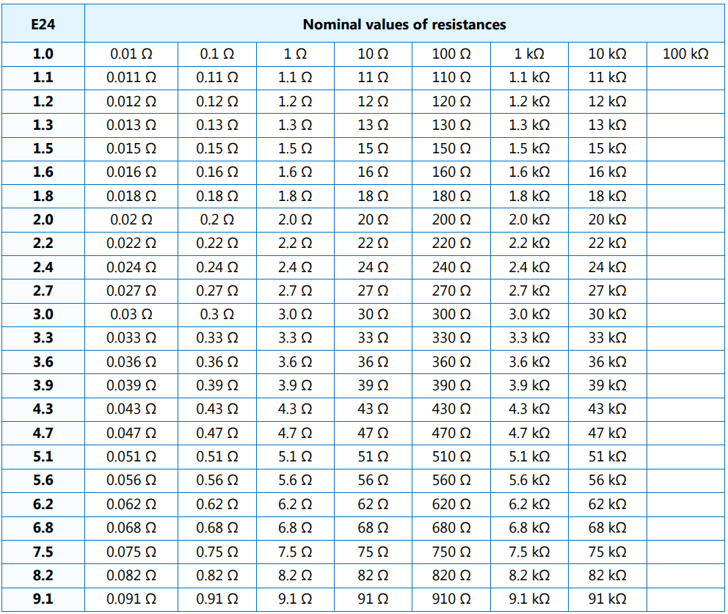

=20000 []

* 1. Define (choose) $R_{4}$ (E24 nominal values range)

$R_{4}=\frac{R_{3}}{2}=$ 10000 [Ω]

* 1. Calculate C1 and C2 value in your model

$C_{1}=C_{2}=\frac{1}{2πR_{1}f_{test}}$ =3.9789 [uF]

* 1. Define (choose) C1=C2 (E24 nominal values range)

=3.9 [uF]

* 1. Define *f*0 in Hz calculated from C1, C2, R1, R2 real values

$f_{0_calculated}=\frac{1}{2πR_{1}C_{1_real}}=$ 4080.896 [Hz]

* 1. Define *f*0 in from simulation results of Wien bridge with ideal operational amplifier

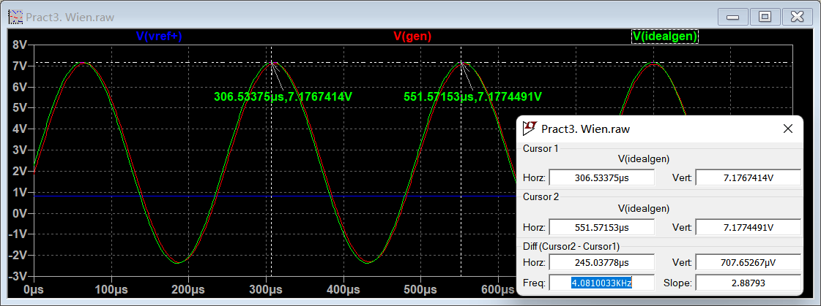

Figure 1. Results with ideal operational amplifier simulation

$f_{0_ideal}=$ 4081.003 [Hz]

* 1. Define *f*0 in from simulation results of Wien bridge with real operational amplifier

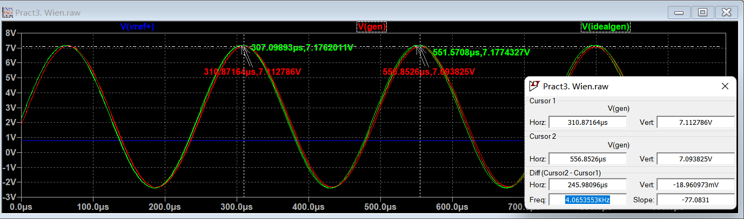

Figure 2. Results with real operational amplifier simulation

$f_{0_real}=$ 4065.3553 [Hz]

# Conclusions

Conclusions should contain:

1. Values of $f_{0_real}$, $f_{0_ideal}$, $f_{0_calculated}$

$f_{0_real}=$ 4065.3553 Hz

$f_{0_ideal}=$ 4081.003 Hz

$f_{0_calculated}$ =4080.896 Hz

1. [Optional] Which resistor and capacitors correspond to the required parameters? Try to find a set of capacitor and resistors which could provide required frequency.

$R_{1}=$ 10000 [Ohm]

$R_{2}=$ 10000[Ohm]

$C_{1}=C_{2}$ =3.9[uF]